Forces & Motion
Push It!

Mr. Beadle – Rm 202

www.vhmsscience.weebly.com

Name: _____________________________________ Period: ___________

Lab Activities | Score
Forces & Motion Experimental Design | /72

Scientific Method & Experimental Design

1 Experimental Test Question & Hypothesis /10
Overall Question: How does mass affect the acceleration rate of objects?
Look at the variables that you’re testing and rephrase the overall question into a testable experimental question:

How does (independent variable) affect (dependent variable)?

Investigative question: ( /4)
2 If / Then / Because… Hypothesis: ( /6)
If I (change the independent variable)
then the (dependent variable will change based on expected outcome)
because…(hypothesis – the reason behind the expected outcome)

Your Hypothesis: ( /6)
If
Then
Because

3 Experimental Design: /10
Summarize your experimental idea. (Hint, look at your if/then statement).

Materials Needed  (Bullet Points, Quantities & Items) | Step by Step Procedures  (1. 2. 3.)

4 Qualitative Observations (Looking for things that may affect the experiment, or phenomenon that occurs during an experiment).
(min 2): /4

5 Data Table (Quantitative Observations) /20

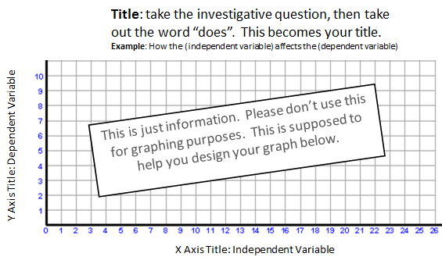
6 Graph
Title: __________________________________________________________________________________ /10

7 Data Analysis (min 4): /8
- What is the range of your independent & dependent data (your high and low)?
- What trends do you see?
- Why do you think this is the case?
- Do you see any points that don’t fit an expected pattern? (Hint: this could be your experimental error)

8 Conclusion: /10
- Summarize
  - Question & Hypothesis
  - Procedures
  - Observations, Trends, Results & Data Analysis related to the question/hypothesis.
  - Experimental errors

- Final Concluding statements
  - Conclusion 1:
    - Does the data support or reject your original hypothesis?
  - Conclusion 2:
    - Explain the “why” behind the phenomenon that you witnessed and provide the reasoning to support why your hypothesis is correct or incorrect.
    - Use your findings to give deeper insights in your research.
- Next Steps:
  - How can we apply what you learned to help explain other phenomenon?
  - What new questions did you have based on your findings & observations?
  - What is the next step in your research

(continued on the next page)

Class discussion & concepts learned:

