Looking into Japan’s Fault
Geological Field Study - Investigation question:
What is going on down there? What’s with all the shaking?
Graph the following:
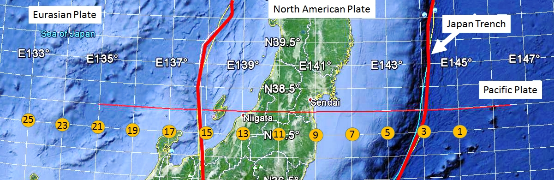
Below is the average epicenter and corresponding depth from the following Japanese region: N35° - N40° Latitude, and E133° and E146° Longitude from 2000 - 2010. Graph the coordinates below and answer the following questions.
Longitude (°East) | Depth (km) | 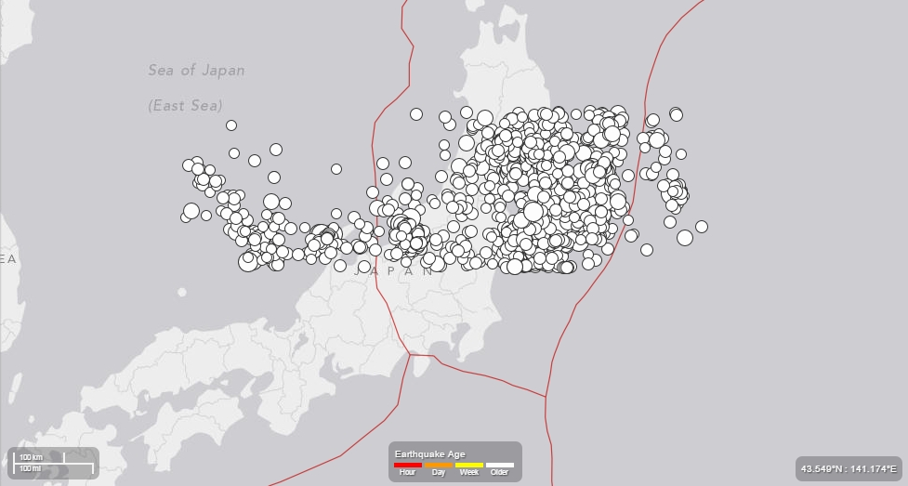  Place a special dot – all by its self for the 9.0 Magnitude Earthquake that hit on March 11, 2011. Place large circles around it.  Its coordinates are: 142.3°East and -29 km down.
145.0 | -15.9
144.5 | -26.1
144.0 | -34.8
143.5 | -35.7
143.0 | -35.9
142.5 | -36.5
142.0 | -43.6
141.5 | -74.9
141.0 | -87.2
140.5 | -92.4
140.0 | -126.0
139.5 | -131.4
139.0 | -154.2
138.5 | -194.8
138.0 | -195.9
137.5 | -245.9
137.0 | -261.2
136.5 | -335.9
136.0 | -352.4
135.5 | -368.4
135.0 | -381.1
134.5 | -408.8
134.0 | -446.2
133.5 | -454.2

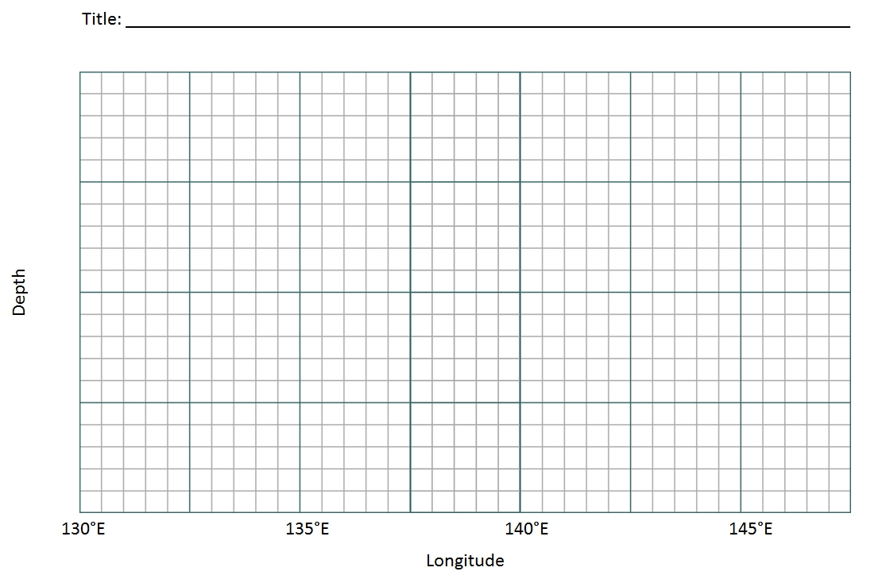

Graph Activities
The graph you drew is the average depth of real earthquakes within smaller regions in Japan. In 2011, as a result of the 9.0 earthquake, Japan moved eastward 8 ft. The Pacific plate moved towards Japan 79 ft. Armed with this information, use the map to do the following on your graph.
- Graph an individual spot for the large earthquake that occurred on March 11, 2011. It’s coordinates are: 142.3°East & -29 km down
- Use the map to indicate where Japan would be on your graph.
- Use the map to indicate where the trench is on your graph.
- Use the map to indicate where the pacific plate is on your graph
- Draw arrows describing the direction between the two plates on your graph and on your map.
Questions:
- What is that line going down? What is the connection between the line and all of the earthquakes?

- Explain why are there no earthquakes in the other areas of the graph?

- Why do you think the graph is jagged?

- How might this graph help to explain why we had a large earthquake in 2011?

Putting it all together – reflections on your investigation:
With the direction of the plate’s motion, and the depths of all of those earthquakes, write a paragraph or two explaining what you think is going on deep down there.

