**Scientific Method**

**A way of knowing & Learning how nature works.**

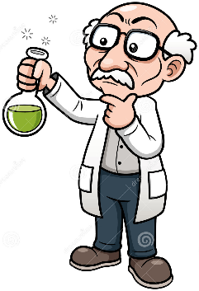

**Mr. Beadle – Rm 202**

**www.vhmsscience.weebly.com**

**Name: _____________________________________**

**Period: ___________**

|  |  |
| --- | --- |
| **Lab Activities** | **Score** |
|  |  |
| Vocabulary | /20 |
| Experimental Lab Design | /1xx |
| Field Research | /20 |
| Black Bottle | /69 |
| Facts v. Inferences | /26 |
|  |  |
| Score Total: | /2xx |

**Vocabulary:** (Use a dictionary or science textbook to complete the words below)

*(****On page 934*** *find the definitions for the following terms)*

/20

1. **Word: Observing**
   1. Definition:_______________________________________________________________________________________________________________________________________________________________
2. **Word: Inferring**
   1. Definition:___________________________________________________________________________

____________________________________________________________________________________

*(****On Page 938****, find the definition in the paragraphs)*

1. **Word: Hypothesis**
   1. Definition:_______________________________________________________________________________________________________________________________________________________________
2. **Word: Variable**
   1. Definition:_______________________________________________________________________________________________________________________________________________________________
3. **Word: Independent Variable** (Manipulated)
   1. Definition:_______________________________________________________________________________________________________________________________________________________________
4. **Word: Dependent Variable** (Responding)
   1. Definition:_______________________________________________________________________________________________________________________________________________________________
5. **Word: Controlled Experiment**
   1. Definition:_______________________________________________________________________________________________________________________________________________________________
6. **Word: Data**
   1. Definition:_______________________________________________________________________________________________________________________________________________________________
7. **Word: Conclusion**
   1. Definition:_______________________________________________________________________________________________________________________________________________________________
8. **Evidence**
   1. Definition:_______________________________________________________________________________________________________________________________________________________________

**Experimental Lab Design Sheet**

/1

**Lab Question: How many drops will a penny hold?**

|  |  |
| --- | --- |
| 1. **Observations** | 1. **Data** |
|  | |  |  |  | | --- | --- | --- | | Trial | Penny 1 | Penny 2 | | 1 |  |  | | 2 |  |  | | 3 |  |  | | Average |  |  | |

|  |
| --- |
| 1. **Background Knowledge** |
| 1. **Original Group Question** |
| 1. **Original Answer:**   **What is your own individual possible explanation for the observation your group chose to focus on? What is your own individual answer to the scientific question above?**  **\***(Please keep your own answer – and not make it one with the rest of the group). |

**Experimental Design:**

|  |  |
| --- | --- |
| 1. **Variables /10** | 1. **Revised Cause & Effect Question /4** |
| What are the variables associated with your question & hypothesis?  What is your *independent variable*?      What is your *dependent variable*?      List a few *controlled variables*? | The revised cause & effect question examines & combines the original question and hypothesis together.  How does (*independent variable*) affect (*dependent variable*)?  **Your question**: |
| 1. **Revised Hypothesis: /4** | |
| Example:  **If** I (change the independent variable)  **then** the (dependent variable will change based on expected outcome)  **because…**(**hypothesis** – the reason behind the expected outcome)  **Your Revised Hypothesis**:  If  Then  Because | |

|  |  |
| --- | --- |
| **Experimental Design: /10** | |
| 1. **Describe Your Overall Experimental Idea** | |
| 1. **Experimental Procedures:**   How are you going to carry out your experiment?  Be sure that you set up a step by step approach detailing each set of procedures.  (Think of a recipe book w. materials and procedures). | 1. **Materials** |
| 1. If your hypothesis is correct, what possible outcome(s) are you expecting to see? | |

|  |
| --- |
| 1. **Qualitative Observations:** (What you see, smell, hear, feel, but please don’t taste)  **/4** |
|  |

|  |
| --- |
| 1. **Data Table /20** |

|  |  |  |  |  |
| --- | --- | --- | --- | --- |
|  |  |  |  |  |
|  |  |  |  |  |
|  |  |  |  |  |
|  |  |  |  |  |
|  |  |  |  |  |
|  |  |  |  |  |
|  |  |  |  |  |
|  |  |  |  |  |
|  |  |  |  |  |
|  |  |  |  |  |

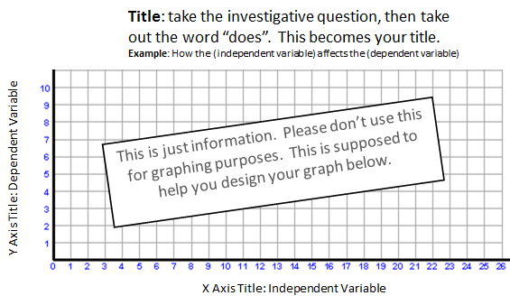

1. Graph

Title: ______________________________________________________________ **/10**

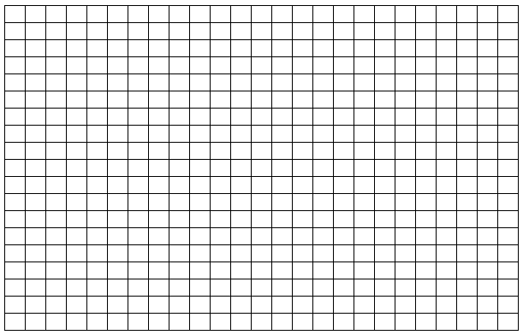

|  |
| --- |
| 1. **Data Analysis** (min 4): **/8** |
| * What are your high points? * What are your low points? * What trends do you see? * Why do you think this is the case? * Look for clues that might answer your revised question. |
| 1. **Conclusion: /10** |
| * Summarize   + **Q**uestion & Hypothesis   + **P**rocedures   + **O**bservations, Trends, Results & Data Analysis related to the question/hypothesis.   + **E**xperimental errors - things that occurred during the experiment that was not controlled or consistent. * Final Concluding statements   + **C**onclusion 1:     - Does the data support or reject your original hypothesis?   + **C**onclusion 2:     - Explain the “why” behind the phenomenon that you witnessed and provide the reasoning to support why your hypothesis is correct or incorrect.     - Use your findings to give deeper insights in your research. * Next Steps:   + How can we apply what you learned to help explain other phenomenon?   + What new questions did you have based on your findings & observations?   + What is the next step in your research?       (continued space on the next page) |
|  |

**References**

/4

*(This section is for the background research that you may have used in the background knowledge section).

Last, First (date) “*Title of the article*”, publishing source <complete web address goes here>

**Field Research**

/20

Write a short paragraph on what you learned about today’s activities.

Black Bottle Inquiry

/69

Watch your teacher and record observations with the black bottle. Your teacher will repeat the same demonstration several times. Your job is to record as many different observations as possible using as many of your senses as possible. After ten times, use the observations just recorded and make an inference about the inside of the bottle to explain what you have just observed. Then draw your inference in the bottle illustrated below. You may use words also to describe your drawing on what is inside the bottle.

/24

|  |  |  |  |
| --- | --- | --- | --- |
| Test  # | **Procedures** | **Results/Observations** | **Inference**  (What does this mean) |
| 1 |  |  |  |
| 2 |  |  |  |
| 3 |  |  |  |
| 4 |  |  |  |
| 5 |  |  |  |
| 6 |  |  |  |
| 7 |  |  |  |
| 8 |  |  |  |

**Hypothesis from 1st set of observations**

**Model of how it works A possible explanation for a set of observations**

**(AKA: a hypothesis)**

**/4 /4**



Black Bottle Inquiry

**Question**: *How in the heck does that crazy black bottle work?*

In this next section – look at the hypothetical model and explanation that you and your group created. Next devise an experiment that will test your hypothesis.

*OUR GROUPS EXPERIMENTAL IDEA & PROCEDURES:* /10

1. What are we testing?
2. How are we going to test it?
3. What is your possible outcome that you should expect to see if your hypothesis is correct?
4. Our test results & 1st conclusion:
5. Are the results what you expected to see? If so – what does that mean? If not, what does that mean?

Other people’s tests and results (choose 5 other groups tests to follow). /15

|  |  |  |  |
| --- | --- | --- | --- |
| Test  # | **Procedures** | **Results** | **Inference & Conclusion**  (What does this mean) |
| 1 |  |  |  |
| 2 |  |  |  |
| 3 |  |  |  |
| 4 |  |  |  |
| 5 |  |  |  |

**Final Conclusion**

**Model of how it works Your tested explanation for a set of observations /4**

**/4**  (This includes more evidence from a series of tests)



**Question: /4**

1. What happened to your conclusion of how the bottle worked in light of new evidence?

1. List two things you learned about the process of scientific reasoning or methodology.

Facts vs. Inferences

**Introduction**

/26

Scientists are constantly trying to separate truth from fiction. In order to do this, we have to carefully observe the world around us. Through careful observation, you will be able to figure out any problem put before you. The trick is separating facts from simple guesses.

Which of the statements below are factual observations, and which are inferences? Underline the facts in the paragraph below and circle the inferences.

**/10**

“Imagine that you are a homicide detective and that you have just arrived on the scene of a murder. As you walk to the front door of the house you notice that the rain outside has finally stopped. The front door is locked. You pry open the door and go in. Mrs. Williams is lying in bed. She is dead. The bedroom window faces a neatly kept garden. The window is open and there are several small puddles of water between Mrs. William’s bed and the window. The woman is wearing a pearl necklace and there is a bottle of pills on the night table near the bed. Mr. Williams is out of town on business when you try to phone him.

Later that day you tell your boss that because Mrs. Williams was still wearing her pearls, robbery could not have been the motive. It was obviously a case of murder. The murderer must have come in through the bedroom window and killed Mrs. Williams. The puddles of water were left by the murderer’s shoes.”

**Fact**: Something that is actually observed.

**Inference**: A conclusion or an opinion that follows logically from something observed.

**Even More Inferences**

Answer the questions listed below. Most questions can be solved by using outside knowledge and clues from the text to make an inference. *(2pts each)*

1. James licked the final square, posted it at the top corner of the envelope and dropped it in the large blue box. He hoped it would get there in time. Nobody likes a late birthday message.
   1. What was James doing? ____________________________________________________
2. I just can’t figure them out. Sometimes I get so frustrated. Like when I ask the file to save, and I come back and hour later and it has erased my paper. Those are the things that just irritate me. I also can’t stand all these goofy names, ‘mouse’, ‘web surfing’, who ever made up such nonsense.
   1. What is frustrating the man? _______________________________________________
3. Maurice loved the feeling of being launched at such fast speeds. He looked forward to the twists and turns, and the upside down loops. The park had gotten so expensive that his family could only afford to go once a year, so Maurice would count down the days until he could feel his hair blowing in the wind as he raced around the track.
   1. Where does Maurice’s family go once a year? __________________________________
4. Of all the chores Tavon had around the house, it was his least favorite. Folding the laundry was fine, doing the dishes, that was alright. But he couldn’t stand hauling the large bags over to the giant sliver canisters. He hated the smell and the possibility of rats. It was disgusting.
   1. What chore does Tavon hate? ______________________________________________
5. The campers sat at the campfire, laughing and having a good time when a strange noise came from the woods. The campers suddenly became silent and sat very still as they could hear a rustling in the bushes. They had heard that bears were known to have lived around this area and therefore began to panic. Suddenly, the creature appeared from the bushes. It was hardly a bear. In fact the large whiskers, twitching nose, and floppy ears couldn’t have scared anyone.
   1. What is the animal that visits the camp? ______________________________________
6. He gave a speech in front of a boisterous crowd. Flags were perched all along the pulpit and he talk about what could be done to improve the lives of everyday Americans. Only a few months later he would be sworn into office, promising to work hard to lead America.
   1. Who is this person giving the speech? ________________________________________
7. He loved all the characters. That was the best part of the show. Homer, Marge, Bart, they all made him laugh. It was nice to sit down, smile, and not worry about a thing after a long day of working.
   1. What show does this person watch to relax? ___________________________________
8. “To be or not to be, that is the question,” he would recite those famous works from his favorite playwright. He loved Hamlet, and Mac Beth, but his favorite, well his favorite had to be A Midsummer Night’s Dream.
   1. Who was this person’s favorite playwright? ___________________________________